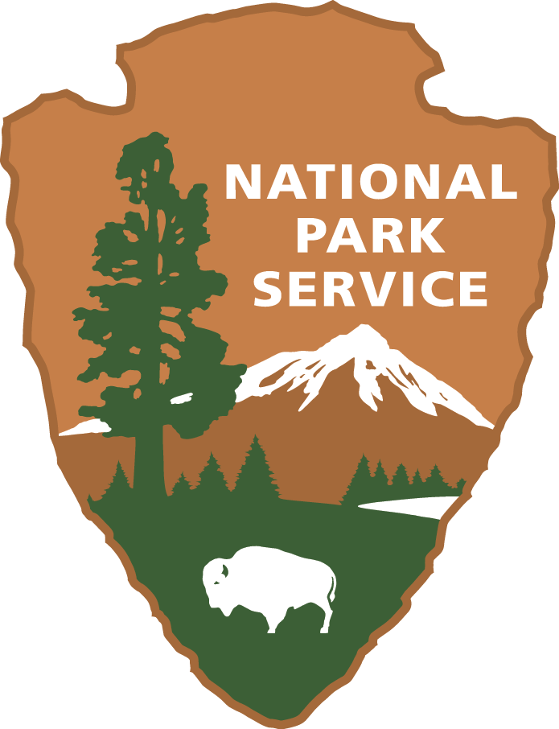
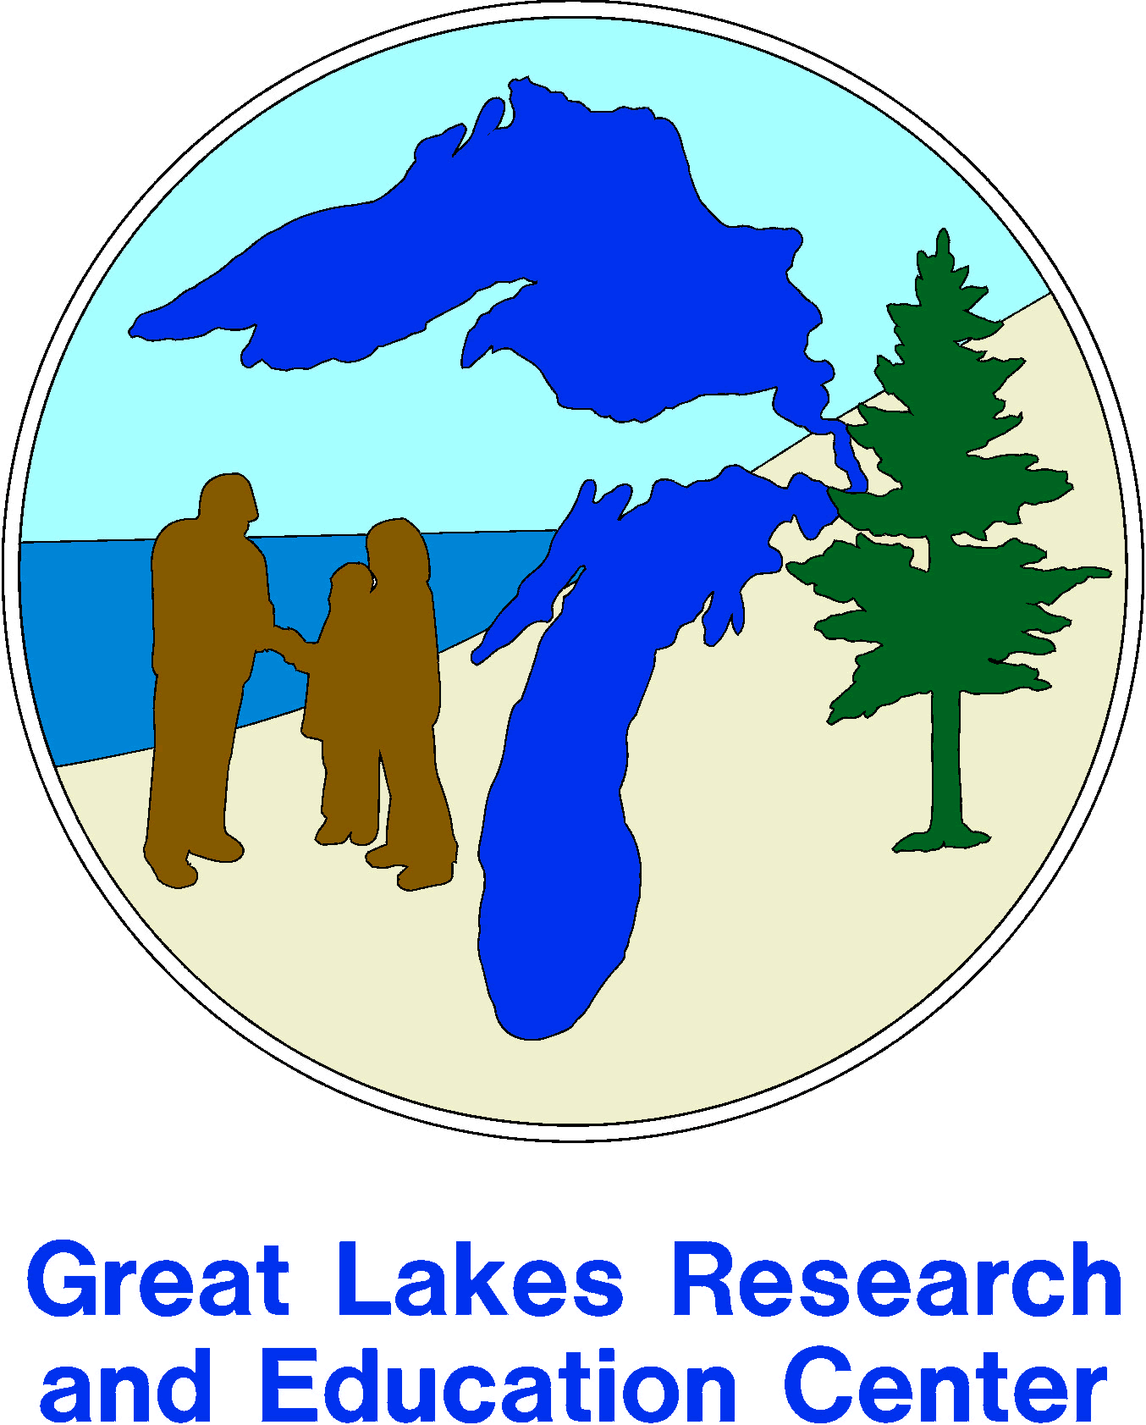
Pollinator Stewardship Intern
Great Lakes Research and Education Center
Indiana Dunes National Lakeshore

About the Great Lakes Research and Education Center
The Great Lakes Research and Education Center (GLREC) is located in the Indiana Dunes National Lakeshore (Porter, IN) and serves 11 national parks in Indiana, Illinois, Michigan, Wisconsin, and Minnesota. We are part of a network of Research Learning Centers established by the National Park Service to facilitate the use of parks for scientific inquiry, promote science literacy and resource stewardship, and integrate science into park resource management, educational outreach programs, and the visitor experience.
The Indiana Dunes National Lakeshore is located along the south shore of Lake Michigan. It consists of about 15,000 acres of dunes, wetlands, prairies, and forests. It is about 60 driving miles from Chicago, and close to train service.
Job description
The Pollinator Stewardship Intern will work with GLREC staff, national park interpreters, and partners to develop programs and materials to educate visitors about the ecosystem benefits provided by native bees, and how they can support native pollinators. The park has about 2 million visitors annually so the public has significant interaction with the interpretive staff. Additionally, the intern will work with the GLREC research coordinator to collect data for a native bee survey in the park. Specifically, the intern will be tasked with 1) organizing a citizen science “Bee Blitz” activity to assist U.S. Fish and Wildlife efforts for locating populations of the endangered Rusty Patched bumble bee; 2) developing educational materials, interpretive programs, and social media content on native pollinators; 3) conducting field work using standardized protocol; and 4) processing samples and preparing specimens for identification by experts. Additionally, the intern will assist with other natural resource projects as needed including, but not limited to vernal pool research, invasive species removal, and water quality monitoring.
Requirements and Working Conditions
This position is well suited for a highly motivated student who is enthusiastic about biodiversity conservation issues, environmental monitoring, and science outreach. The ideal candidate will have an interest in environmental education and be enthusiastic about working outdoors and collecting data. The candidate must be able to work both independently and collaboratively and be able to communicate effectively with diverse groups. Desired qualifications include strong oral and written communication skills and a course or background in entomology. A willingness to work with insects is essential.
The intern is required to be currently working toward a degree (or a recent graduate) in general biology, natural resources, environmental science, agriculture, entomology, or a related field and have at least a 3.0 GPA. Undergraduate students completing their junior or senior year or first-year graduate students are strongly encouraged to apply.
Prior to starting this position a government security background clearance will be required.
Work will consist of approximately 50% time in the office, 25% field, and 25% laboratory. Field work includes potential exposure to extreme weather conditions, poisonous plants, biting insects, ticks, and wild animals. Sampling may be performed in potentially hazardous areas including steep slopes. The park will provide safety training in use of facilities and equipment. The intern will be provided with tick prevention guidelines and equipment. NPS will provide Department of Interior computer security training. The intern will have access to NPS computers after security training is obtained.
Compensation will be in the form of a stipend through the Indiana Sustainability Development Program. The intern will work full time for 10 weeks beginning in May and ending in August. Exact beginning and end dates are negotiable. Interns will be required to attend a bootcamp on the IU Bloomington campus from May 14-18.
Subsidized park housing may be available with two months advance notice. Houses are furnished and include single or shared bedrooms, kitchen facilities, and bathrooms. Only linens are required.
Applicant must have a valid driver’s license and a good driving record. The participant will need a personal vehicle to travel between lodging and park sites, although carpool options with other interns may be a possibility.
Feedback and evaluation
The intern will be given regular feedback on progress and performance. Success in the internship will be determined by the completion of specified projects in a professional and timely manner. By participating in both research and educational activities, the intern will be able to explore a variety of career options and develop skills important to both fields. The intern will gain valuable communication skills by preparing and presenting programs on native pollinators to park staff, educators, citizen scientists, and the general public in both professional and informal settings. The intern will receive training in research methods including standard sampling protocols, specimen processing, basic insect identification and taxonomy, and data management. Through interactions with seasonal and permanent park staff, the intern will learn about the federal service and NPS culture.

